HSC Remote Access via Citrix

Table of Contents
Logging into Citrix 4
Installing Citrix 5
Using Citrix 8
Accessing Files on the HSC Server 9
Accessing Outlook Using Citrix 12
Saving Files to the HSC Server 16
Citrix Settings 17

Revised: October 2009
© 2009 The Learning Center at the
Robert C. Byrd Health Science Center,
West Virginia University, Morgantown, WV
Network documents can be accessed remotely using Citrix via the WVU Masterapps website at http://masterapps.wvu.edu.

To use Citrix, you must fill out the Remote Access form and have that form approved by your dean before you can access the Citrix server. The Citrix form is located on the ITS website at http://www.hsc.wvu.edu/its/Forms.

When you log into the Masterapps website, you will have access to the programs that have been made available to you on the Citrix server, and the files on the server that can be accessed by those programs.

After you open a program on the Citrix server, that session remains open even if your browser crashes. You have one hour from the time you are disconnected to return to Masterapps and log back into Citrix and save your open files. After one hour, the session will be closed.

Sessions can remain open and idle for three hours. After three hours of inactivity, the session will be forced to close.

These time limits are in place because leaving a session open on the server can cause problems, eventually overloading the server if enough sessions are left open.

Logging into Citrix
The address of the Masterapps website is https://masterapps.wvu.edu. When you log in to Masterapps, you will use your Master ID login, which is the first part of your e-mail address. After that, you need to append the specific server, which for HSC employees will be @hs.wvu-ad.wvu.edu.

Example: jdoe@hs.wvu-ad.wvu.edu

To Log in to Masterapps (Citrix)
- Open your web browser. Citrix works best in Internet Explorer 6 or higher.
- In the location bar, type in http://masterapps.wvu.edu.
- You will be redirected to a secure page on the WVU website.
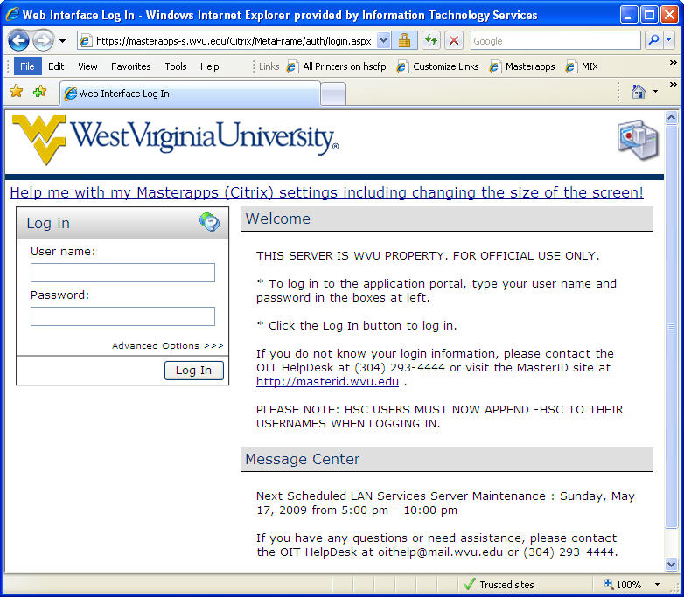
- In the User Name text box, enter your Master ID (the login you use to access your e-mail) followed by @hs.wvu-ad.wvu.edu.
- In the Password box, enter your Master ID password (the password you use to access your e-mail).
- Click the Log In button or press the Enter key.
- Please wait patiently while you are logged in.

Installing Citrix
When you log into the Masterapps site for the first time, you will be prompted to install Citrix on your computer. You may also need to have your browser stop blocking pop-up windows.

To Install Citrix
- Internet Explorer may initially block the installation of Citrix. If it does, click once in the blue bar beneath the toolbar.
- From the menu select Download File.
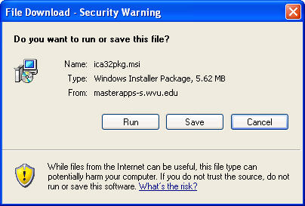
- The File Download – Security Warning dialog box opens. Click Run.
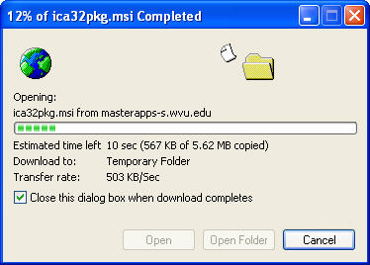
- The program is downloaded to your computer.
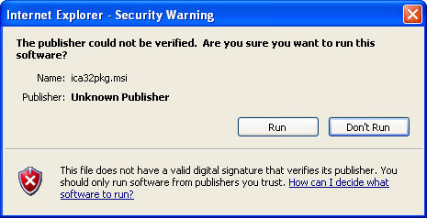
- In the next Internet Explorer – Security Warning dialog box, click Run.
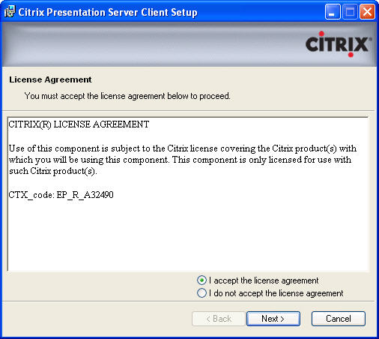
- The Citrix Presentation Server Client Setup dialog box opens. Click I accept the license agreement.
- Click Next.
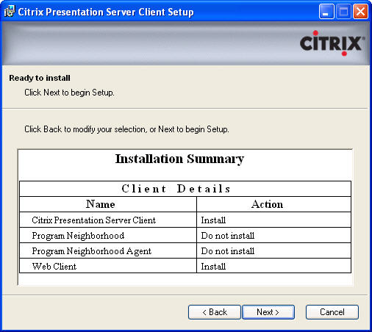
- In the Installation Summary dialog box, click Next.
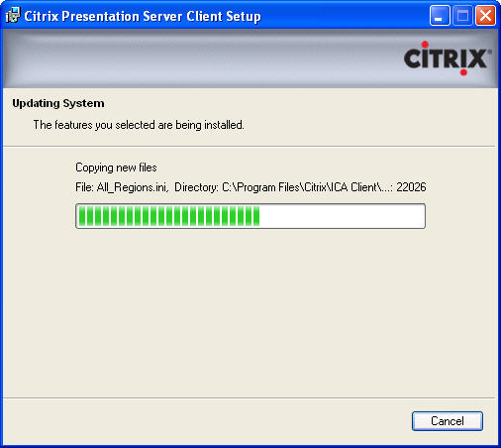
- Citrix is installed. Please wait patiently.
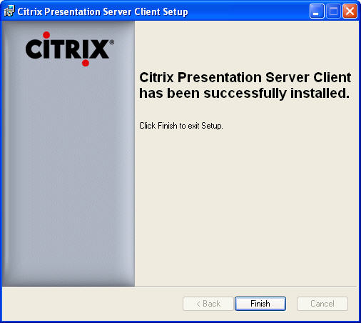
- Once the installation is complete, click Finish.

Using Citrix
Once you are logged into Citrix, the window will display the available applications.

Microsoft Office 2007 will be available to all users of the Citrix system. Other applications will be made available to individuals as needed.

With the exception of Access, multiple people can access the files on the server at one time. Please be aware of this when saving files that are used by multiple individuals.

Because sessions are saved on the server while you work, when using applications through Citrix, you MUST exit the applications before logging out. Failure to close the application will leave the session running on the server, which will cause the server to slow down and eventually crash.
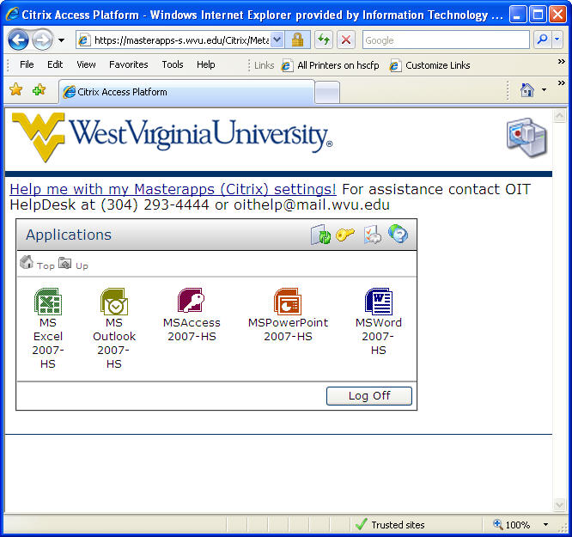

To Use Citrix
- Click once on the application you would like to use.
- Please wait patiently while the program opens in a new tab or window (depending upon your browser settings).

Accessing Files on the HSC Server
The selected application or program opens in a new tab or window (depending upon your browser settings). From within the selected program window you can access your files on the HSC server.

Because sessions are saved on the server while you work, when using applications through Citrix, you MUST exit the applications before logging out. Failure to close the application will leave the session running on the server, which will cause the server to slow down and eventually crash.

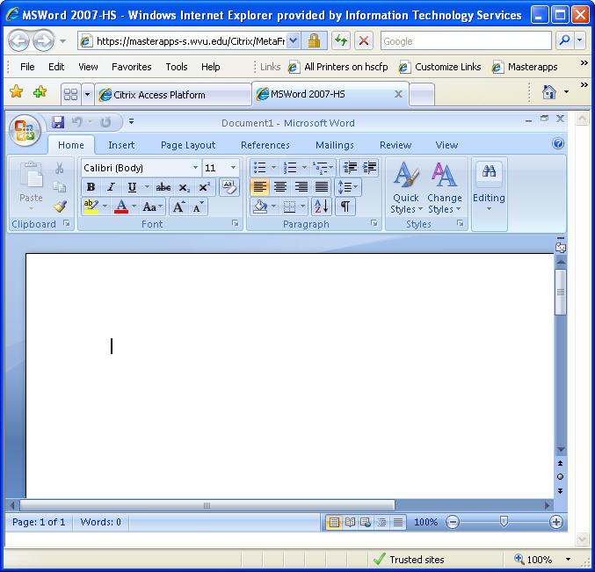

To Access Your Files on the HSC Server
- Open the program from which you want to work.
- Within the program, access the Open dialog box as you normally do.
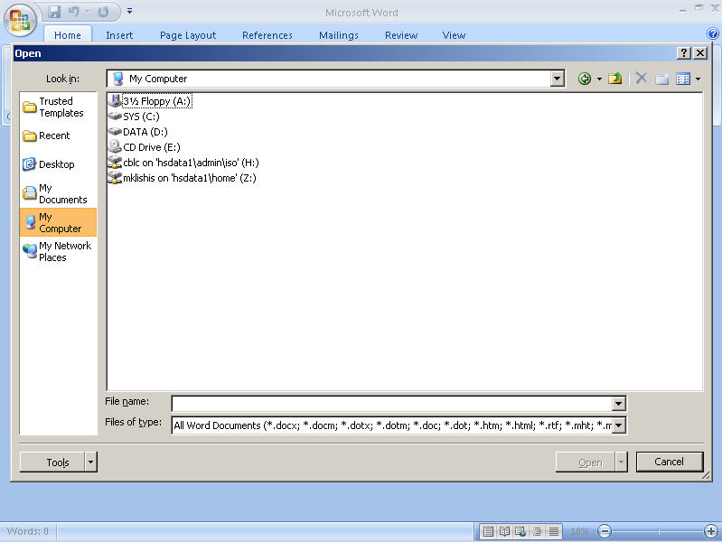
- In the Open dialog box, select My Computer.
- Select the desired network drive.
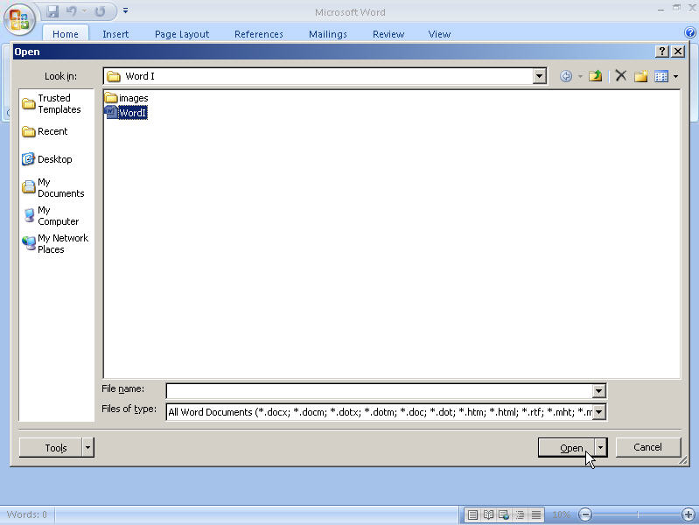
- Browse to the location on the network drive where your file is located.
- Select the file.
- Click Open.
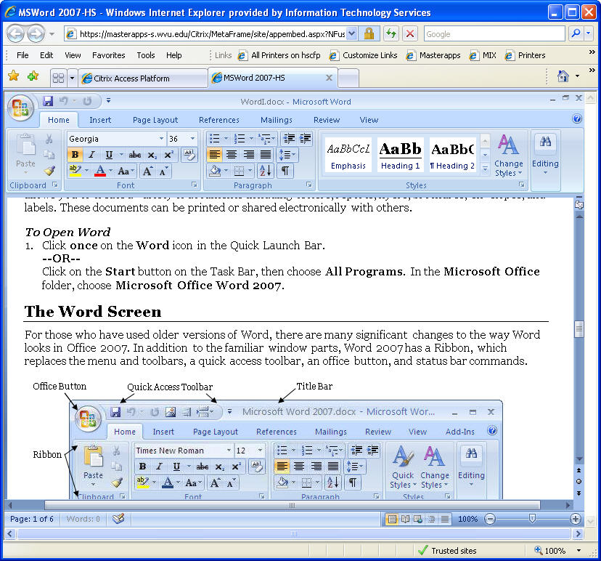
- The selected file opens.
- Use the program as you normally would.
- When you are finished, save the file as you normally would, then close the program, using Office Button and then Exit.

Accessing Outlook Using Citrix
The first time you access Outlook via Citrix, you will need to configure Outlook. You will only need to do this once, and from then on Outlook will be available from all computers you use remotely.

To Configure Outlook Using Citrix
- Log into Citrix.
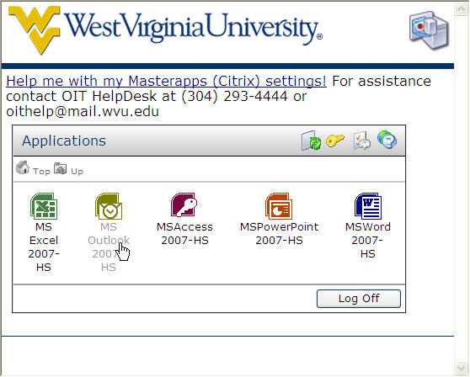
- In the Applications box, click MS Outlook 2007 HS.
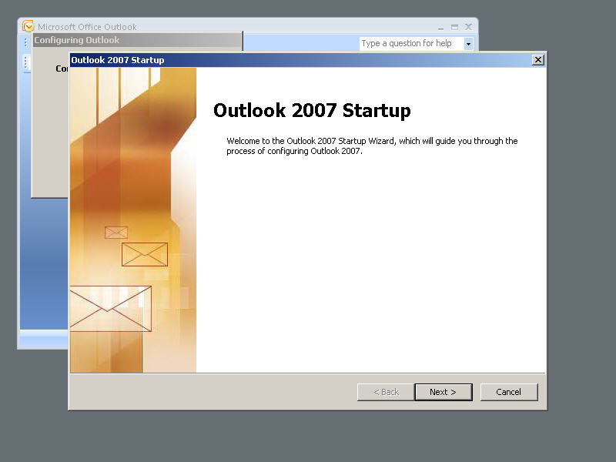
- The Wizard opens. Click Next.
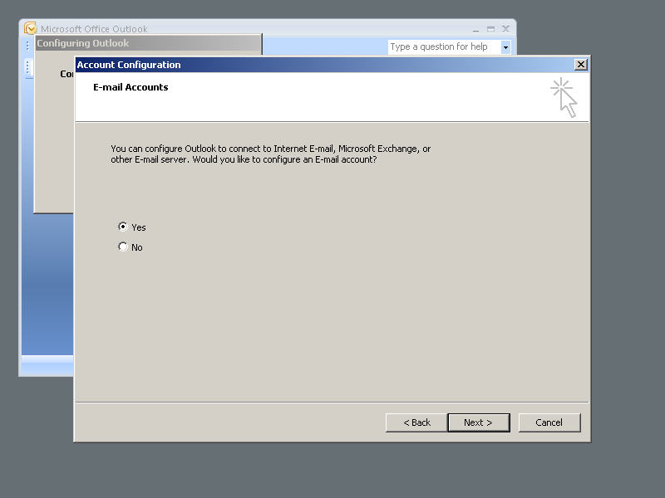
- In the first account configuration dialog box, click Yes to configure Outlook.
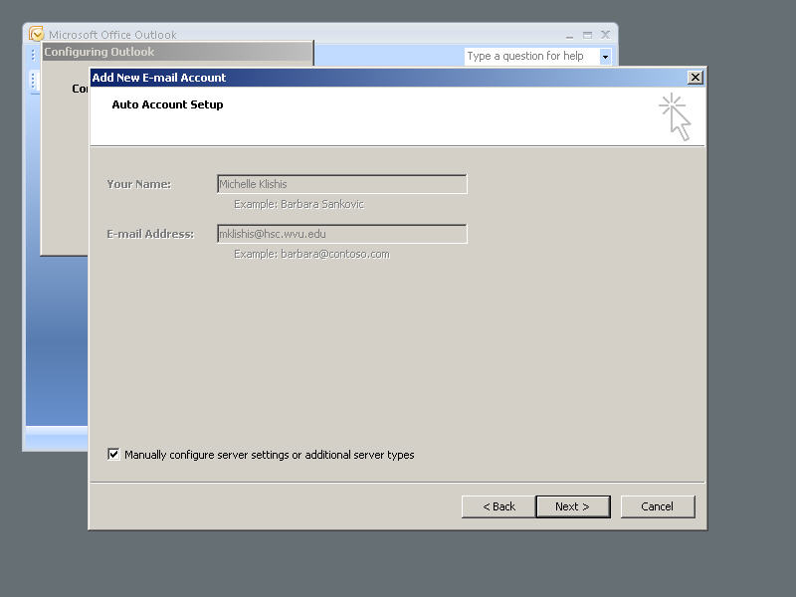
- In the lower right corner, place a check in the Manually configure server settings or additional server types box.
- Click Next.
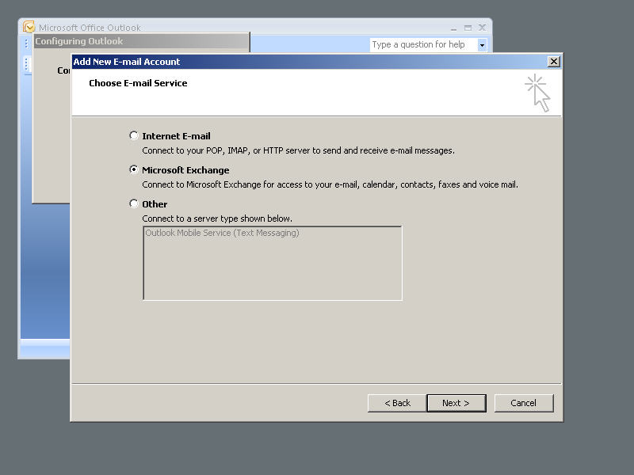
- In the Choose E-mail service dialog box, select Microsoft Exchange.
- Click Next.
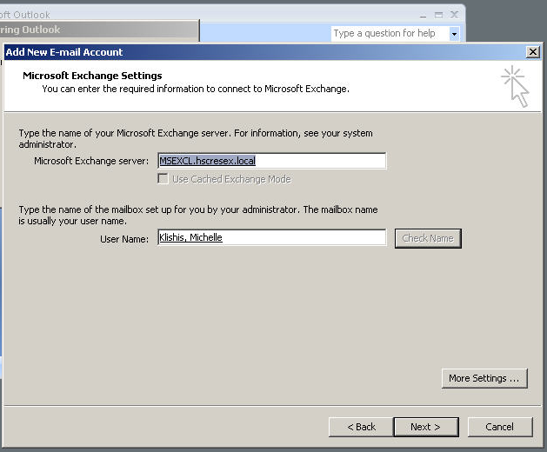
- Enter the Exchange Server: msexcl.hscresex.local.
- Enter your User Name.
- Click the Check Name button. The server and your name should be underlined.
- Click Next.
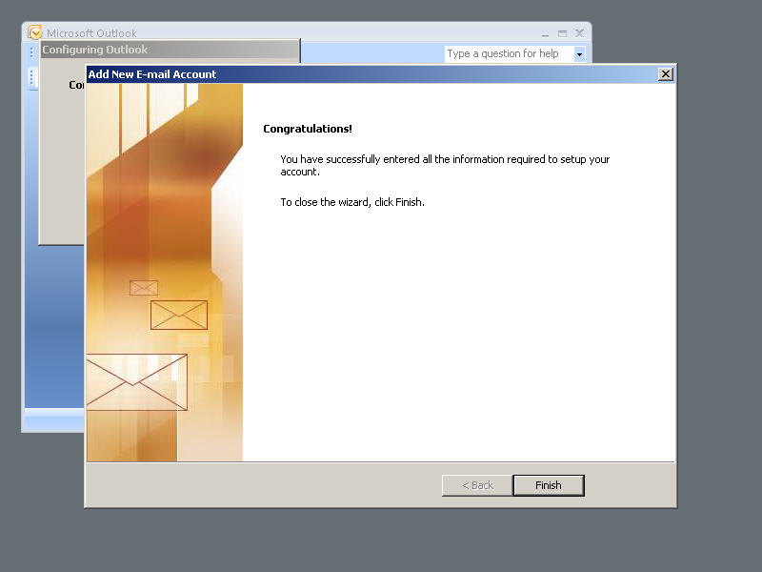
- Click Finish.
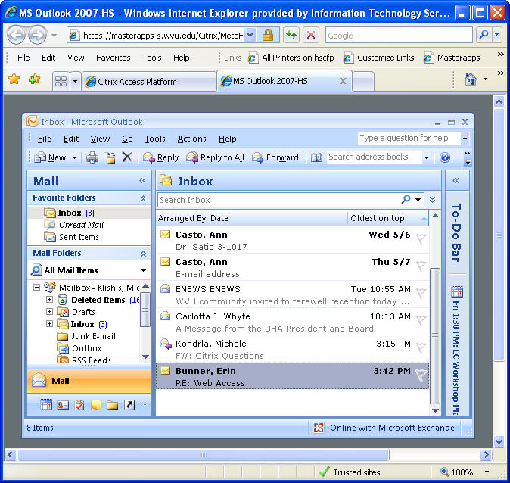
- Outlook opens displaying your mailbox.

Saving Files to the HSC Server
In addition to accessing files already on the HSC server, you can also create and save new files to the network drive.

To Save a New File to the HSC Server
- Create the file in the desired application as you would locally.
- Save the file, by clicking the Office Button and then choosing Save As.
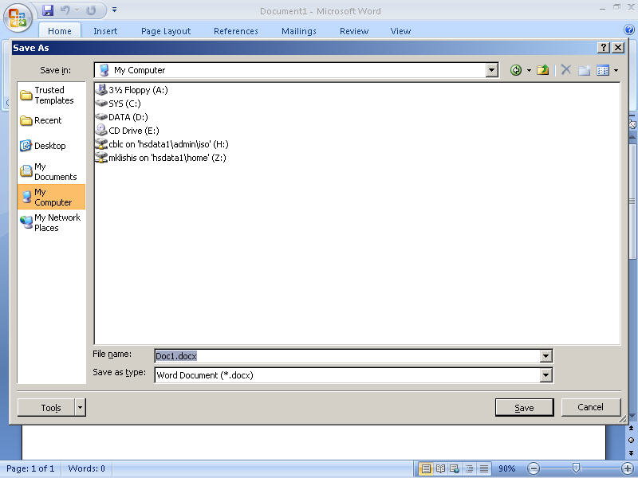
- In the Save As dialog box, select My Computer.
- Select the desired network drive.
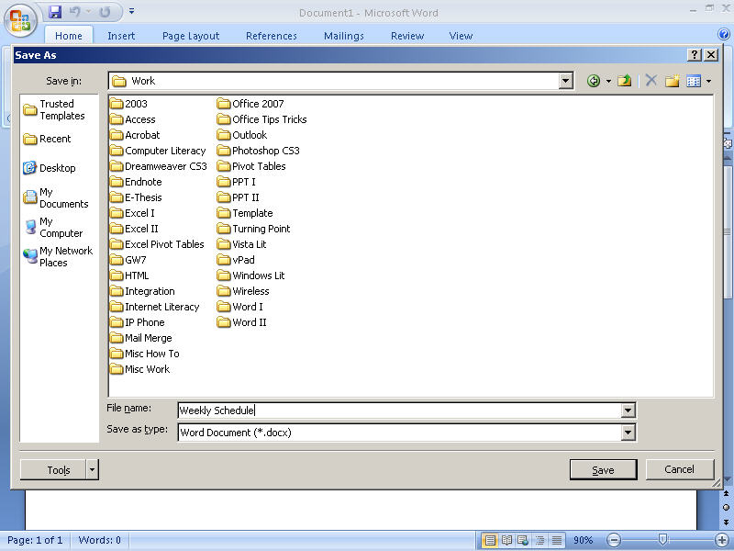
- On the network drive, select the desired folder.
- Save the file as you normally would.

Citrix Settings
The Citrix application may open in a window that is too large for your computer or personal preference.

To Change the Display Size
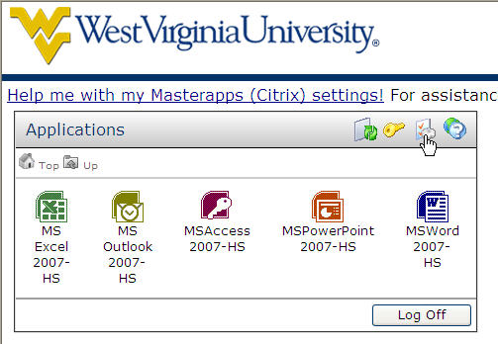
- In the Applications Box, click the Settings button.
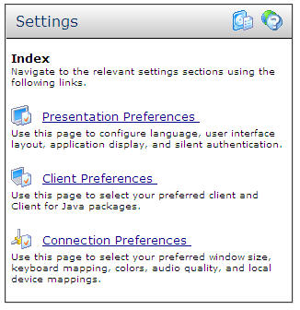
- In the Settings Box, click Connection Preferences.
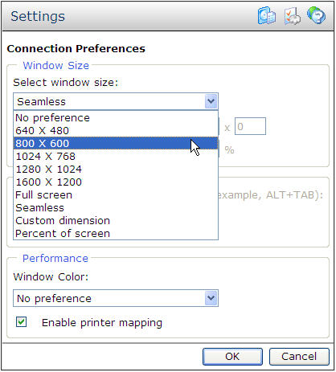
- In the Settings Box, select the desired window size from the Select window size drop down menu.
- Click OK.
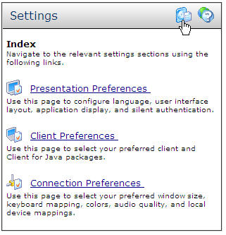
- Click the Applications button to return to the Application list.

If you would like more information about other Learning Center workshops, please or visit our website at http://www.hsc.wvu.edu/its/LC or call the Learning Center at 293-3631 ext 5.

- NOTES -

